PROJECT-51
AI Documentation Writer
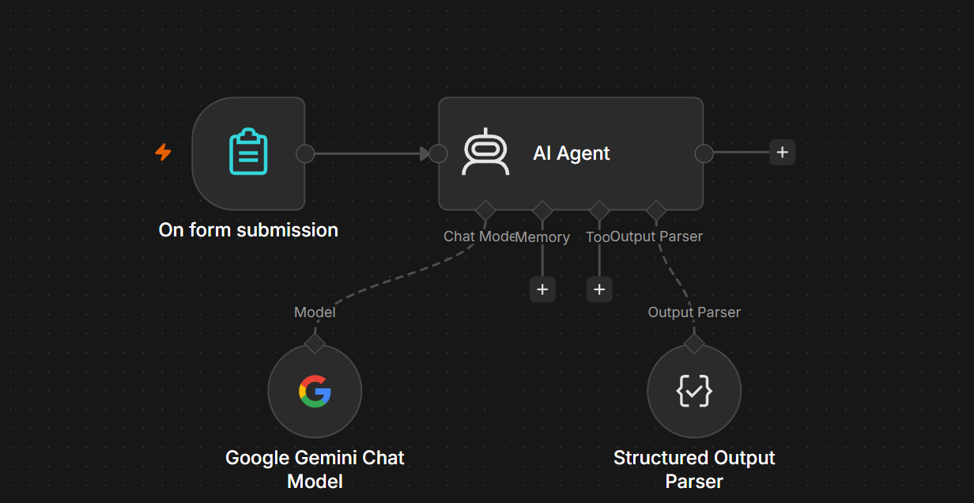

1. Project Objective
The AI Documentation Writer takes information entered through an n8n form and generates structured technical or project documentation.
It can generate:
- Project overview
- Objective
- Features
- Requirements
- Workflow
- Installation/setup steps
- Usage instructions
- Technical details
- Limitations
- Future enhancements
- Conclusion

2. Nodes Required
Use these four nodes:
Main workflow
- On Form Submission
- AI Agent
AI Agent sub-nodes
- Google Gemini Chat Model
- Structured Output Parser
Not required
❌ Vector Store
❌ Data Loader
❌ Text Splitter
❌ Embeddings

3. Step 1 — On Form Submission
Add:
On Form Submission
Create these fields.
Field 1 — Project Name
Type: Text
Project Name
Example:
AI Expense Categorizer

Field 2 — Project Type
Type: Text
Project Type
Example:
AI Automation

Field 3 — Project Description
Type: Text Area
Project Description
Example:
An AI-powered system that analyzes employee expenses
and automatically categorizes them.

Field 4 — Technologies
Type: Text Area
Technologies
Example:
n8n, Google Gemini, AI Agent, Structured Output Parser

Field 5 — Features
Type: Text Area
Features
Example:
Expense categorization
Expense type detection
Reason generation
Structured JSON output

Field 6 — Target Audience
Type: Text
Target Audience
Example:
Employees and finance teams

Field 7 — Documentation Type
Type: Text
Documentation Type
Example:
Technical Documentation
You could later make this a dropdown with:
Technical Documentation
User Guide
API Documentation
Project Documentation
Product Documentation
README

4. Example Form
Your form should look like:
Project Name:
AI Expense Categorizer

Project Type:
AI Automation

Project Description:
An AI-powered system that analyzes employee expenses
and automatically categorizes them.

Technologies:
n8n, Google Gemini, AI Agent, Structured Output Parser

Features:
Expense categorization
Expense type detection
Reason generation
Structured JSON output

Target Audience:
Employees and finance teams

Documentation Type:
Technical Documentation

5. Step 2 — AI Agent
Connect:
On Form Submission
↓
AI Agent
Use the normal workflow connection.

6. AI Agent Prompt
Select:
Prompt (User Message)
→ Define below
Use:
Create professional documentation based on the following project information.

Project Name:
{{ $json['Project Name'] }}

Project Type:
{{ $json['Project Type'] }}

Project Description:
{{ $json['Project Description'] }}

Technologies:
{{ $json['Technologies'] }}

Features:
{{ $json['Features'] }}

Target Audience:
{{ $json['Target Audience'] }}

Documentation Type:
{{ $json['Documentation Type'] }}

Create documentation containing:

1. Project Overview
2. Objective
3. Key Features
4. Technologies Used
5. System Workflow
6. Setup Instructions
7. Usage Instructions
8. Input and Output
9. Limitations
10. Future Enhancements
11. Conclusion

Make the documentation clear, professional and easy to understand.

7. System Message
Use:
You are an AI Documentation Writer.

Your job is to create professional and well-structured
documentation based only on the project information provided.

IMPORTANT RULES:

1. Use only the information provided by the user.
2. Do not invent technologies, features, APIs, credentials,
integrations or system behavior.
3. Clearly explain the purpose of the project.
4. Organize information using clear sections.
5. Explain the workflow in a logical order.
6. Make setup instructions easy to follow.
7. Clearly describe inputs and outputs.
8. Mention limitations when relevant.
9. Suggest realistic future enhancements.
10. Use professional technical language.
11. Keep explanations understandable for beginners.
12. Do not claim that an unprovided integration exists.
13. Return the result using the required structured output format.

8. Step 3 — Google Gemini Chat Model
Add:
Google Gemini Chat Model
Connect it to the AI Agent's:
Chat Model input.
Correct connection:
Google Gemini Chat Model
↓
AI Agent

9. Step 4 — Structured Output Parser
Add:
Structured Output Parser
Connect:
AI Agent
↓
Output Parser
↓
Structured Output Parser

10. JSON Output Format
Use Generate from JSON Example.
Paste:
{
"title": "AI Expense Categorizer",
"project_overview": "An AI-powered automation that analyzes employee expense information and categorizes expenses automatically.",
"objective": "Reduce manual effort involved in reviewing and categorizing employee expenses.",
"key_features": [
"Expense categorization",
"Expense type detection",
"Reason generation",
"Structured JSON output"
],
"technologies_used": [
"n8n",
"Google Gemini",
"AI Agent",
"Structured Output Parser"
],
"workflow": [
"Employee submits expense information through the form",
"The AI Agent receives the submitted information",
"Google Gemini analyzes the expense",
"The Structured Output Parser formats the result"
],
"setup_instructions": [
"Create an On Form Submission node",
"Add the required form fields",
"Add an AI Agent",
"Connect Google Gemini Chat Model",
"Connect Structured Output Parser",
"Test the workflow"
],
"usage_instructions": [
"Open the form",
"Enter the required project or expense information",
"Submit the form",
"Review the generated result"
],
"input": [
"Employee name",
"Expense amount",
"Merchant",
"Expense description"
],
"output": [
"Expense category",
"Expense type",
"Reason"
],
"limitations": [
"AI output depends on the quality of the submitted information",
"The system should not invent information that was not provided"
],
"future_enhancements": [
"Store documentation in Google Sheets",
"Add email notifications",
"Add approval workflows"
],
"conclusion": "The AI Documentation Writer provides a structured way to generate clear and professional project documentation."
}

11. Final Workflow
Your n8n canvas should look like:
┌─────────────────────────┐
│ On Form Submission │
│ │
│ Project Name │
│ Project Type │
│ Description │
│ Technologies │
│ Features │
│ Target Audience │
│ Documentation Type │
└────────────┬────────────┘
│
▼
┌─────────────┐
│ AI Agent │
└──────┬──────┘
│
▼
Structured Output Parser
And:
Google Gemini Chat Model
↓
AI Agent

12. Test Input
Use your own previous project as the test.
Project Name
AI Expense Categorizer
Project Type
AI Automation
Project Description
An AI-powered system that analyzes employee expense
information and automatically categorizes expenses.
Technologies
n8n, Google Gemini, AI Agent, Structured Output Parser
Features
Expense categorization
Expense type detection
Reason generation
Structured JSON output
Target Audience
Employees and finance teams
Documentation Type
Technical Documentation

13. Expected Output
The AI should generate something similar to:
Project Overview

AI Expense Categorizer is an AI-powered n8n automation
that analyzes employee expense information and assigns
appropriate categories.

Objective

The objective is to reduce manual expense categorization
and provide consistent structured results.

Key Features

• Expense categorization
• Expense type detection
• Reason generation
• Structured output

Technologies

• n8n
• Google Gemini
• AI Agent
• Structured Output Parser

Workflow

1. Employee submits expense information.
2. n8n receives the form submission.
3. AI Agent analyzes the information.
4. Gemini generates the classification.
5. Structured Output Parser formats the result.
The exact wording can differ. That's normal.

14. Why This Is a Medium-Level Project
Your earlier projects mostly generated one type of output.
This one generates a complete structured document:
Form
↓
AI Agent
↓
Analyze project
↓
Generate multiple sections
↓
Structured Output
It demonstrates:
- Form input
- Dynamic n8n expressions
- AI Agent
- Gemini
- Prompt engineering
- Structured Output Parser
- Information organization
- Technical writing
- Workflow documentation

15. Optional Advanced Version
Once the basic version works, you can build:
Form
↓
AI Documentation Writer
↓
Structured Documentation
↓
Google Docs
↓
Share / Email
Or:
Form
↓
AI Documentation Writer
↓
Markdown
↓
GitHub
You could also create a documentation pipeline:
Project Information
↓
AI Documentation Writer
↓
AI Reviewer
↓
IF
├── Approved → Save Documentation
│
└── Needs Changes → Rewrite

16. Important Difference: When Would You Need a Vector Store?
For the basic AI Documentation Writer:
Form → AI Agent → Gemini → Output
No Vector Store.
But if you later want:
"Create documentation based on 20 existing company documents."
Then a Vector Store/RAG system becomes useful:
Documents
↓
Embeddings
↓
Vector Store
↓
AI Agent
↓
Documentation
So for your current medium-level version, keep it simple.
Final Architecture
On Form Submission
↓
AI Agent
↙ ↘
Gemini Output Parser
↓
Structured Documentation
This is the correct setup for your AI Documentation Writer.

